# Creating Set’s in the PIM

A set is a class type which links multiple products together with the intention to list them together.

## Create a new class

A set is a new class type and thus needs to be created in the PIM.

Click the *Classes* tab, found under *Product Configuration*.

Click *New Product Class.* Here it will ask you to name your new class and define the class type. The class type for a set is *grouped*.

The type of data for this new class is then determined. Much of the information required for the products are held in their existing classes (for example, inventory is held at the sku level). You may wish to upload a new photo for the set (media), or a new description (description), or make a new category for where the set will be listed.

## Uploading Sets via CSV

Now that the structure for the information has been created, data can now be uploaded.

Under the *Product ta*b, click on the *Manage Jobs* tab*.*

Click the *Download Template* option to load a CSV template for bulk data uploads to the PIM.

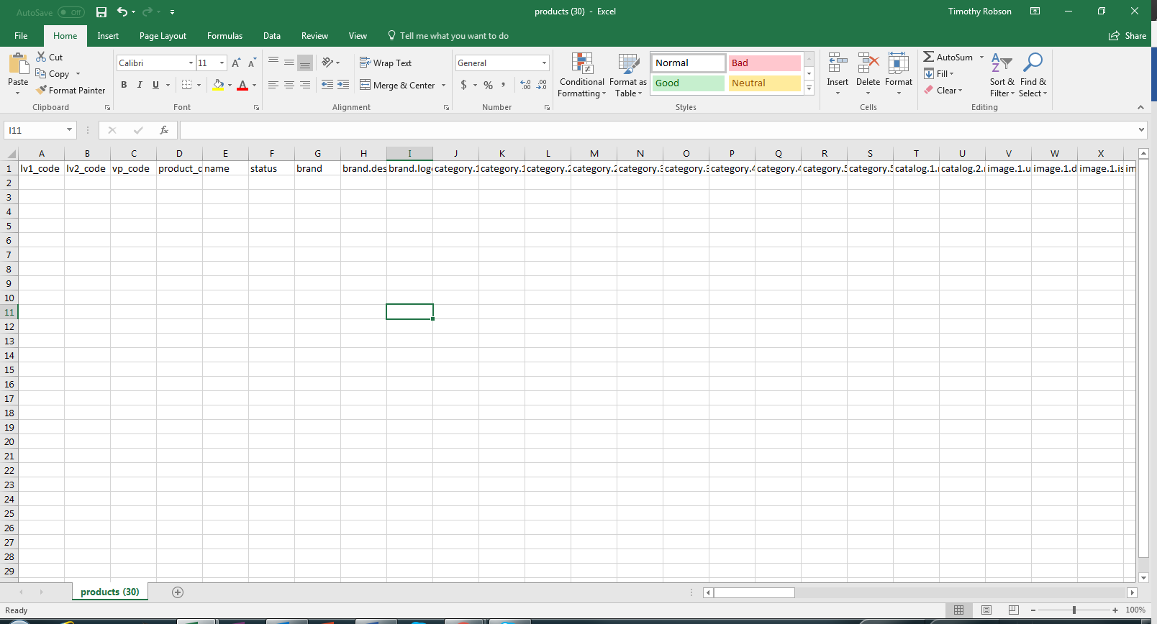

Much like other product data uploads, there are mandatory fields.

These include status, lv1_code, product name, group variation code.

Status must either be "active" or "inactive"

The lv1_code is made up of the class level codes for both of the desired products.

For example, 30462-191-40285-191

The yellow highlighted code above is the product code for the first product, and the blue highlight is for the second product. They are linked, without spaces, by a dash.

The product name would also include names of both the products that are part of the set – For example Bali Hai Slide Tri Bikini Top & Brazilian Bikini Pant.

A grouped product can be at **any** class level. What this means is you can list a set by style. This gives the ability to customise colour and size in the listing. Alternatively, you can list by colour class, leaving only the size to be selected. (This example uses the style-colour-size model, but this is not compulsory)

An important value required in all set uploads is the Group member code. This field links the set to the class of products in the PIM. This is needed for maintaining stock levels, and linking information from the set to the actual product. At the end of the CSV file, populate a cell on the top level with "group_member_code". For every set, the required value in this field is the individual lv1_code for both the products with a | (pipe) in between the two codes for each of the products. For our above example, the format is 30462-191|40285-191

Now upload the data into the PIM by saving the CSV file and pressing the *Upload Files* under the *Manage Jobs* tab.

## Check that it worked

If your upload was unsuccessful, the result field in *Manage Jobs* will show unsuccessful. You can click on the cog at the end of the populated bar and click *Download Response*. This will download a CSV which will identify the errors in the upload line by line. Once you have a successful result go to the next step!

It is good to check if the set worked by going into the actual created set. This can be done in the *Manage Products* field. Here you can click on the blue hyperlinked product code and check the different levels of information have populated the fields. An important one to check is the link between the set and the product under *Variations/Groups.* Both product codes in the set should exist as hyperlinks in this field. You should be able to go to the original product through this hyperlink, thus testing that the link works.